IMPLEMENTATION, INTEGRATION AND TEST PLAN

This section identifies the order in which we planned to implement the subcomponents
of our system and the order in which we planned to integrate such subcomponents and
test the integration. So, in the following section we will explain all our decisions regard to
the integration strategy, elements to be integrated and the testing sequence of
components.

The test are divided in two category:
- unit test
- instrumentation test

The gol of the first kind of test is to test the model’s classes, the support’s classes and the services classes. These tests are implemented using Junit4 library, Mockito and Powered Mockito (in order to mock static methods).

The gol of the second kind of tests is to test the graphical component of the application. In our case we focus on testing the funtionality of each activity, fragment and element. For each activity we found the main functionality and the correct functioning is testing. These test are implemented using espresso freamwork and are runned on Firebase Test Lab.

The first kind of test we implemented was the unit test. Here we test the model and support class.
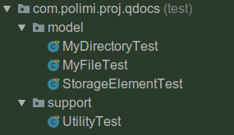

In StorageElementTest class we test the compareTo static method and the “retriveFileBy” (name and key) methods.

In MyDirectoryTest and MyFileTest we test the method of the class MyDirectory and MyFile, for example the method “duplicate” that, given a file, create a copy of it.

In the UtilityTest class is tested “generateQRCode” method that return a bitmap; in this test PoweredMockito is used in order to mock the static methods of Bitmap class. Another method tested here is the “generateCode” method that generate a new code from which provide a new qrcode to associate to a new file.

Once we the unit tests were implemented, we implemented the instrumentation tests:
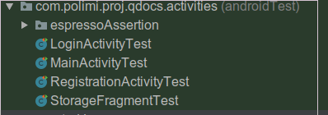

Here we test the main functionality of every activity, such as log a user, register a user, upload a file on the cloud, deleta a file, ext.

